**My Simple CV**

* **My last some websites & CMS & API in hosting server:**

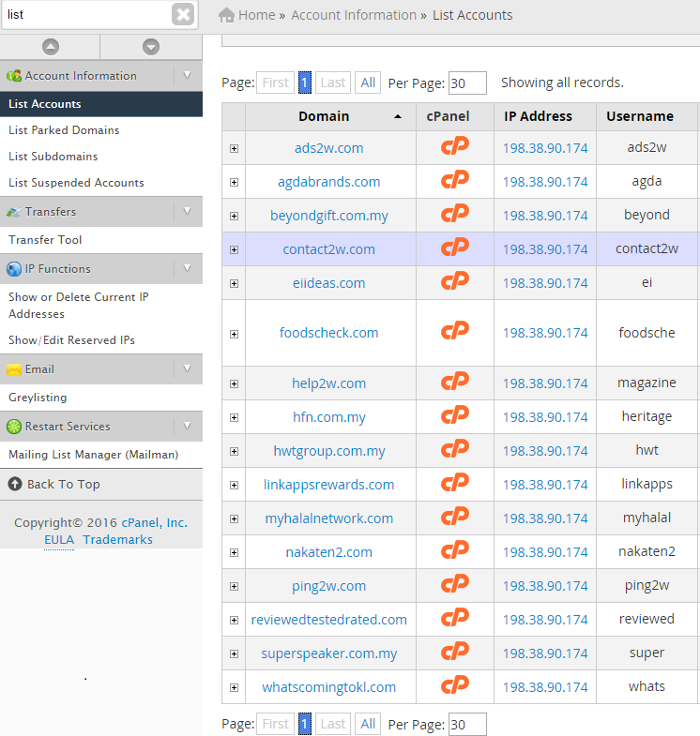

* **My last some android apps in playstore:**

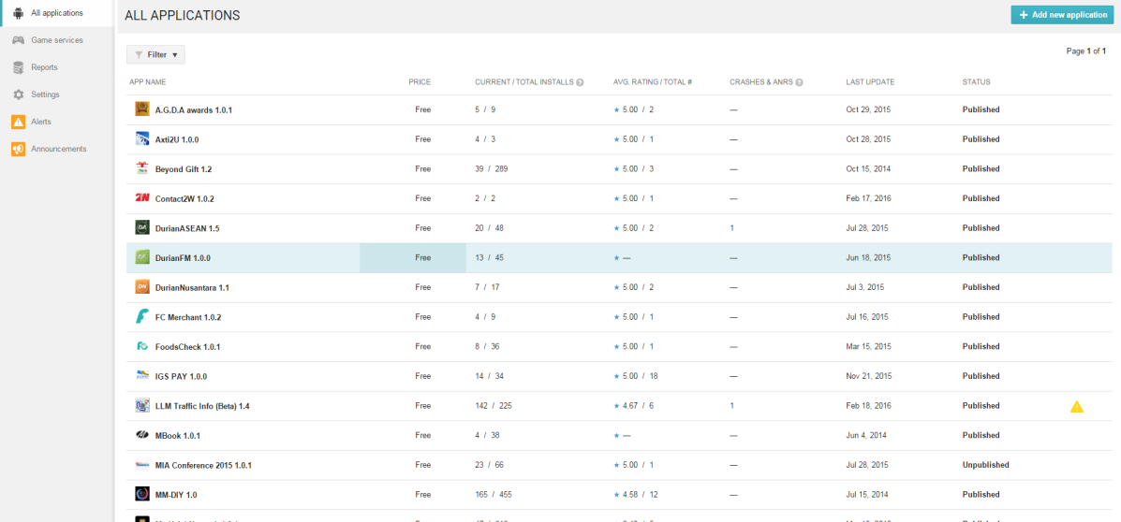

* **My last some ios apps in itunes:**

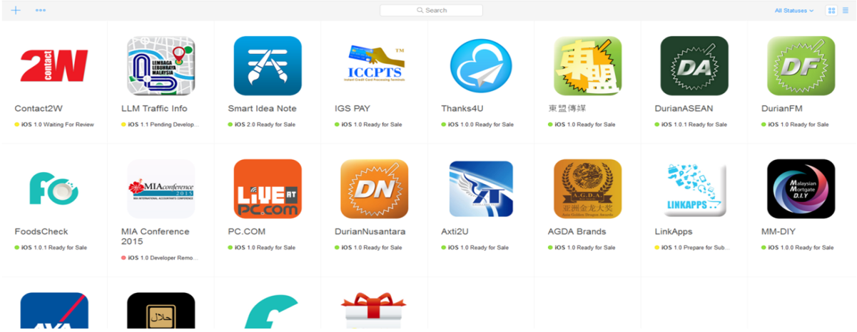

* **Language Skills:**

PHP, PHP Framework (Laravel, Codeignitor)Visual Object-C, HTML5, CSS3, JS(JQuery, Node.js, Angular.js, Express.js, bootstrap, ReactJs, Vue), XML, MySQL, MongoDB, Hybrid Language (ionic, react native)

* **SDK Skills:**

J2EE, Spring, JMF, Laravel, Joomla, Drupal, Zend, AngularJS, IOS SDK, Pods, Android-SDK, Android-NDK, COCOS2d-x & COCOS3d and Corona SDK, Paylpal SDK, Stripe SDK, Facebook SDK, Twitter SDK, XMPP SDK, BBM SDK, Java SDK, Credit Card SDK, In-app purchase SDK, Node.js, Express.js, phongap SDK, XMPP SDK, libjingle SDK, WebRTC, Ionic,Yelp SDK, etc

* **Tool Skills:**

NetBeans, Eclipse, Android Studio, Xcode, Dreamwaver, Editplus, photoshop, illustrator, Visual Code, Git.

* **OS Skills:**

Mac OS, Linux(CentOS, Ubuntu, Fedora, RedHat), ARM, X86

* **Experienced Project Skills:**

1. **Some Web Applications:**

<https://beacon-cloud.biz> : BBN Company Business System

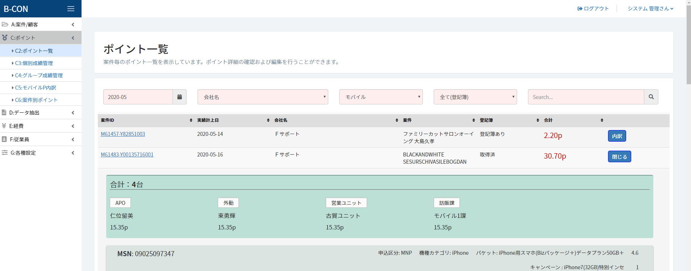

**Used skill: Laravel, Jquery, MYsql, aws ec2 instance, Mail, pusher integration.**

<http://hoya.com.my> : Online Lens Simulation responsive web site.

<http://ww.hakoren.com> : Online social food mobile & web site.

<https://www.esynchrony.com> : Online Dating web site & CMS

<https://www.stadiumastro.com> : Football game news and matches site.

<http://www.light-talk.com/en> : Lecture site using wordpress

<https://hotels.ihusigroup.com> : hotel room reservation system

<http://unicablink.com> : Malaysia taxi booking CMS & API.

<http://www.belloinnovation.com> : bello innovation sdn bhd advertisement site

<http://hfn.com.my> : Online-shopping site

<http://agdabrands.com> : AGDA Brands sdn bhd introduction site

<http://hwtgroup.com.my> : HWT group introduction site

<http://www.rakuten.co.jp>

<http://shoppingfeed.jp>

<https://www.jigsawtrading.com> : Stock Marketing Site

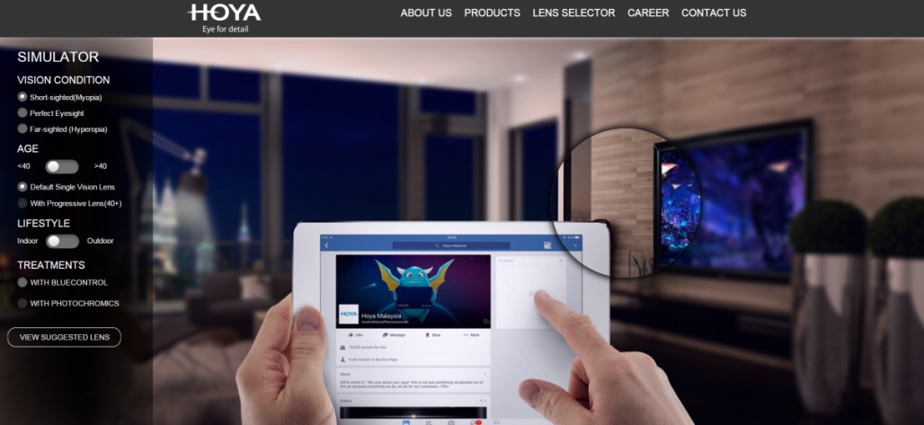

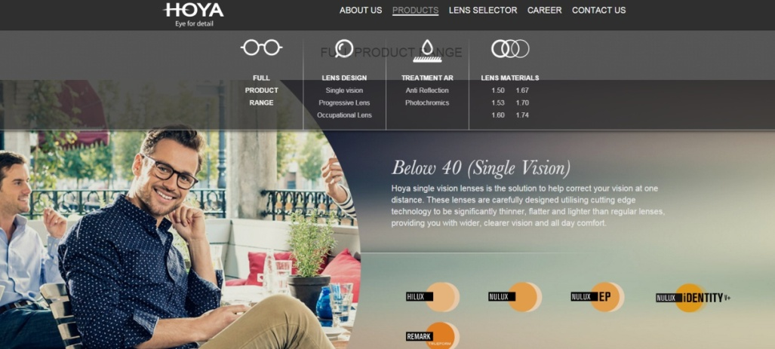

Used skills: lens simulator on web, HTML5, CSS3, Jquery, Kwicks.js, Jssor.js, canvas, iframe. fb integration. CMS

1. **Some Mobile apps:**

**GemFive - malaysia anywhere and anytime shopping app**

http://www.gemfive.com/my/

https://play.google.com/store/apps/details?id=com.gemfive.app&hl=en

https://itunes.apple.com/in/app/gemfive-shopping-malaysia/id1016316315?mt=8

**Orange Eye – Accident detect app.**

https://play.google.com/store/apps/details?id=com.orangeeye

https://itunes.apple.com/us/app/orange-eye/id848189888?mt=8

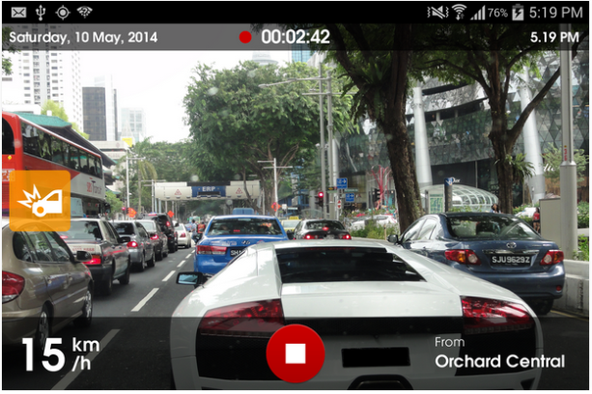 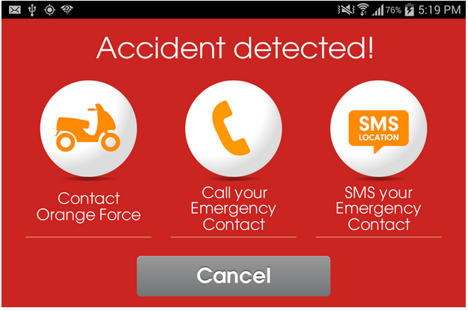

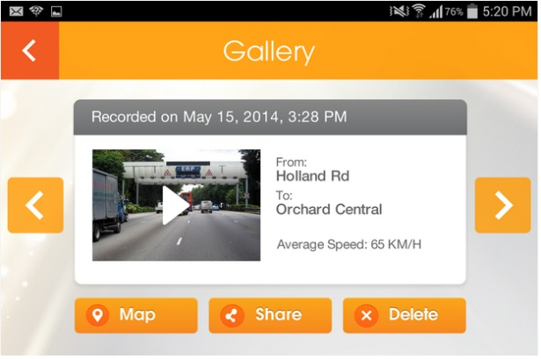 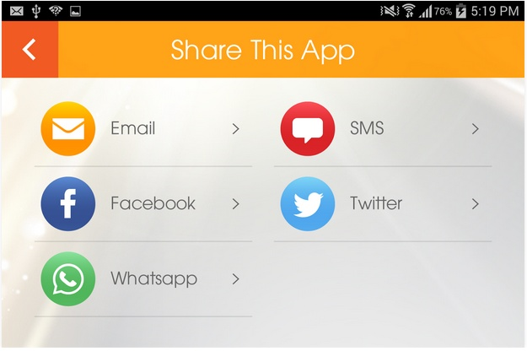

Used skills: gps navigation, vibrate sensor detect, creating video, ffmpeg, video player, auto call, auto sms, auto mail, social networks integrate.

**Moola (where shopping is free) - Online free shopping**

http://www.moola.my/www/moola/Home.aspx?ReturnUrl=%2f

https://play.google.com/store/apps/details?id=com.moola1&hl=en

http://appshopper.com/lifestyle/moola-where-shopping-is-free



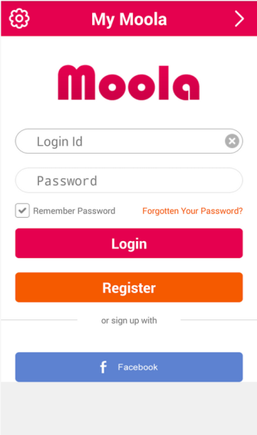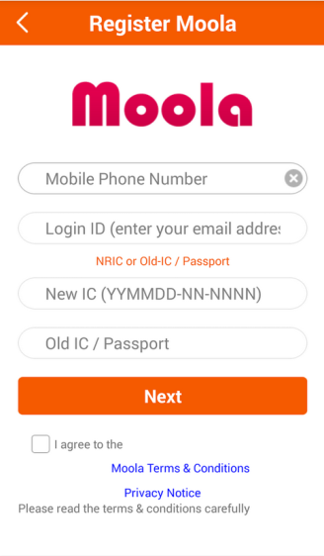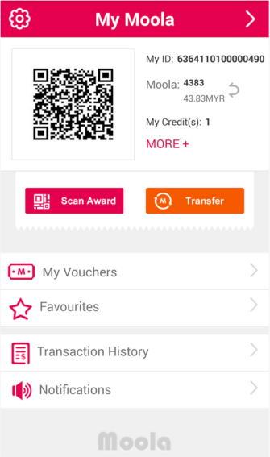

Used skills: own rest API, CMS, Merchant, IC card, Point Concept, GPS, Googld clouding messaging, APN, goole bubble, fb social network integrate.

**Hypoband - Healthcare management app by monitoring skin.**

https://play.google.com/store/apps/details?id=com.myhypobandwatch

https://itunes.apple.com/us/app/hypoband-1.1/id923835315?mt=8

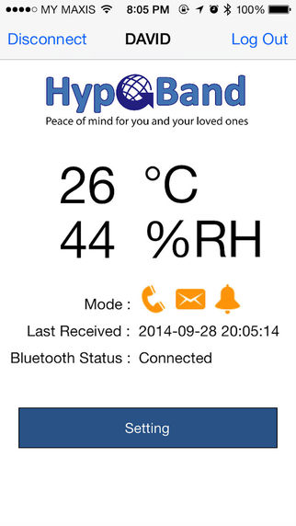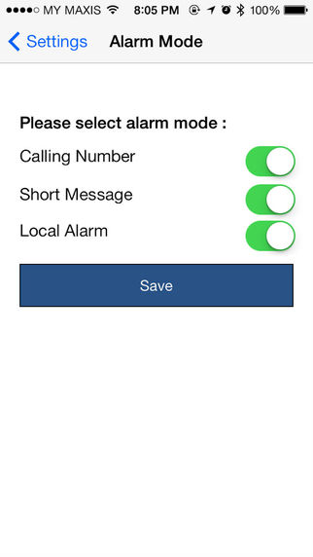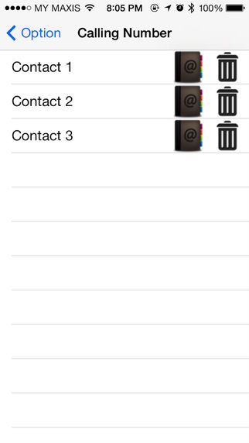

Used skills: BLE-bluetooth, device scanning, google clouding messaging, APN, auto call, sms, email

**Email archive**

Android & IOS & web app - Security Email archive management app.

https://play.google.com/store/apps/details?id=com.emailsecurity.emailarchive

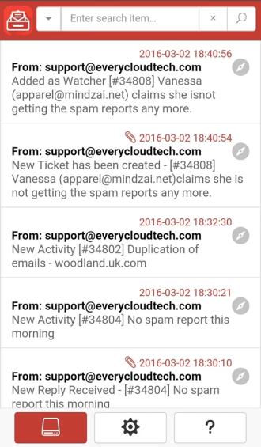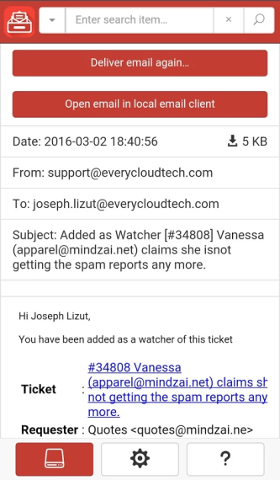

Used skills: cordova framework, angulajs, expressjs, bowerjs, cool security logic

**EveryCloud**

Android & ios & web app - Security Email management app

https://play.google.com/store/apps/details?id=com.emailsecurity.everycloud

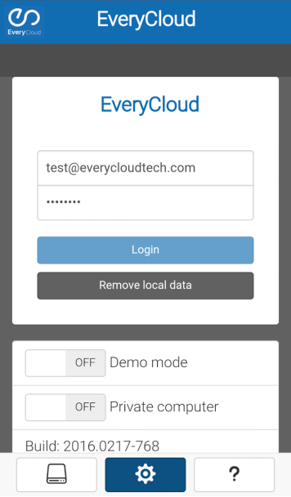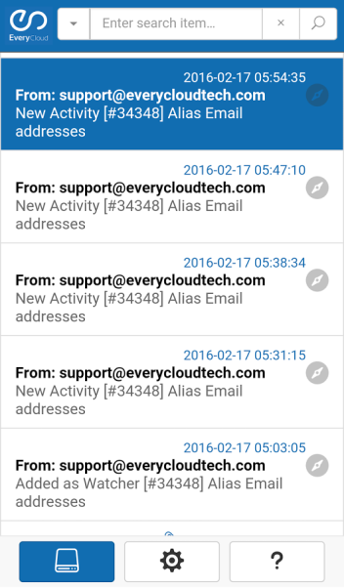

Used skills: cordova framework, angulajs, expressjs, bowerjs

**Mirrativ - Live Video streaming**

https://play.google.com/store/apps/details?id=com.dena.mirrativ

used skills: webrtc, libjingle, RTMP

**ringID - Live Video call app**

https://play.google.com/store/apps/details?id=com.ringid.ring

https://itunes.apple.com/us/app/ringid-free-video-call-voice/id925330759?mt=8

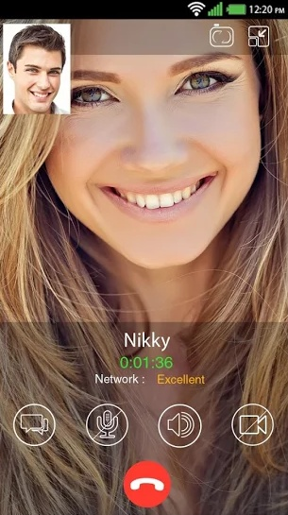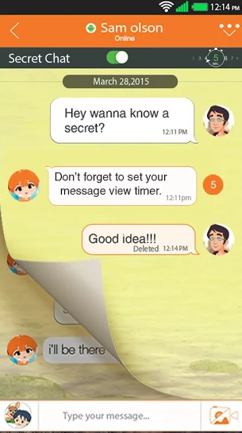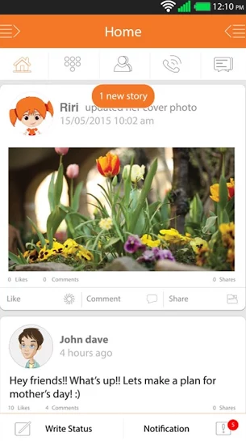

Used skills: webRTC, libjingle, RTMP, google clouding messaging, APN,

**Stadium Astro - Sports news and game match TV app.**

https://play.google.com/store/apps/details?id=com.netcosports.andastro&hl=en

https://itunes.apple.com/my/app/stadium-astro/id513212373?mt=8

Used skills: restAPI integration, Google clouding Messaging, APN, footbal tv app, live streaming, RTMP, RTSP, video player, game match table, big image processing, social network sharing.

**Esynchrony - Online Dating**

https://www.esynchrony.com

https://play.google.com/store/apps/details?id=com.datingtuna.esynchrony&hl=en

https://itunes.apple.com/my/app/real-dating-service-esynchrony/id893845592?mt=8

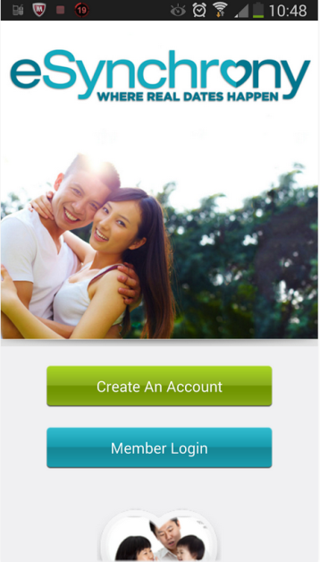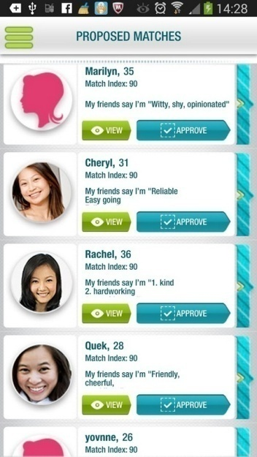

Used skills: Own rest API, CMS, Online dating app, paypal purchase, QA, fb login, Google Cloud Messaging, APN

**Unicablink - KL taxi booking**

http://www.unicablink.com/

https://play.google.com/store/apps/details?id=com.bsmart.unicablink

https://appworld.blackberry.com/webstore/content/23915874/?countrycode=KR&lang=en

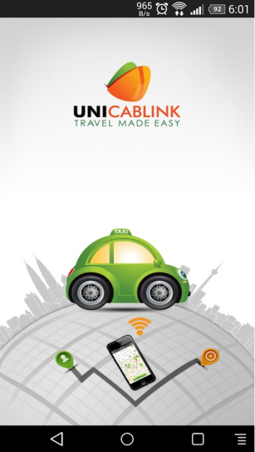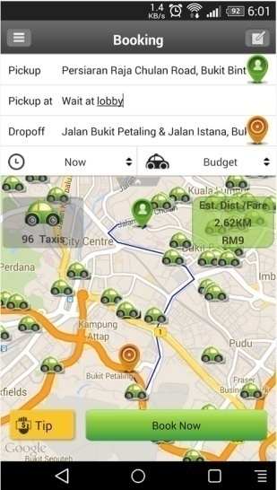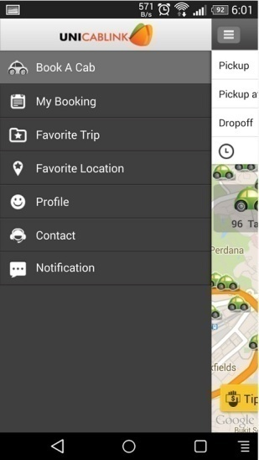

Used skills: CMS, own rest API, Google Cloud Messaging, APN, Booking, GPS, google Map, google bubble, gps navigation,

**Madmathz - number matching game between fb friends.**

https://play.google.com/store/apps/details?id=com.squarefresco.madmathz&hl=en

https://itunes.apple.com/us/app/madmathz-app/id913447995?mt=8

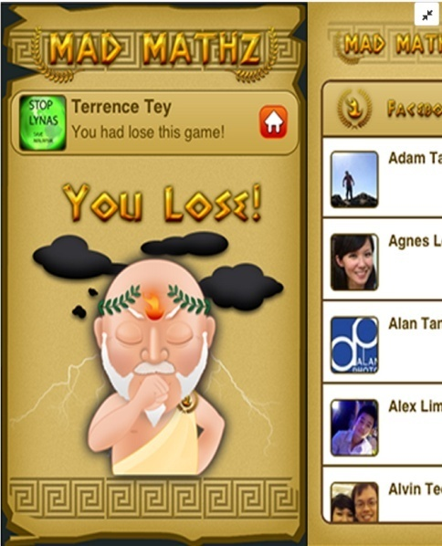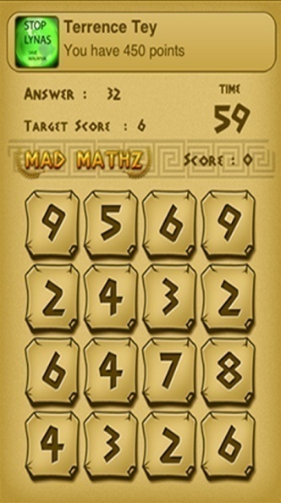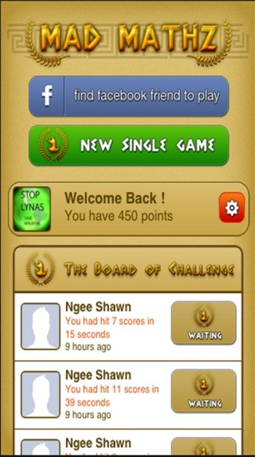

Used skills: fb social network integrate, get friend from fb, fb messenger, canvas, cocos2d-X, Google cloud messaging, APN,

**Stream Crop**

Android & STB & TV app - Rea-time TV live streaming player app

https://play.google.com/store/apps/details?id=com.streamcrop.livebroadcast

used skills: Live video streaming, RTMP, libjingle

**Jigty Jigsaw Puzzles (JJP) – multi puzzle creating and playing**

https://play.google.com/store/apps/details?id=com.outfit7.jigtyfree&hl=en

https://itunes.apple.com/us/app/jigty-jigsaw-puzzles/id672246969?mt=8

Used skills: cocs2d-x, google cloud messaging, APN, In-app purchase, In-app billing



**Smart AXA – Agents managing system of Malaysia AXA company**

http://smartaxaagent.com

https://play.google.com/store/apps/details?id=smart.axa&hl=en

http://appshopper.com/finance/axa-smart-agent

Used skills: google cloud messaging, APN, user auth, CMS, own rest API, web socket chatting, group manage, news

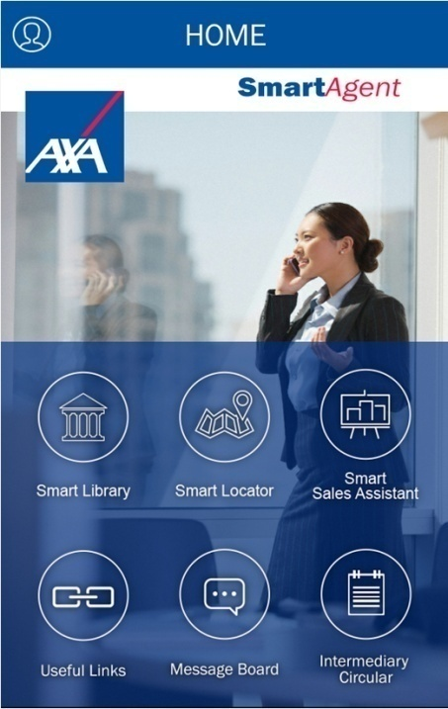

**LLM - highway support system of Malaysia**

http://llmtrafik.llm.com.my

http://llm-traffic-info-beta.android.informer.com/

https://itunes.apple.com/us/app/llm-traffic-info/id1023798777?mt=8

Used skills: google cloud messaging, APN, highway manage, google map, multi bubble on map, social network sharing

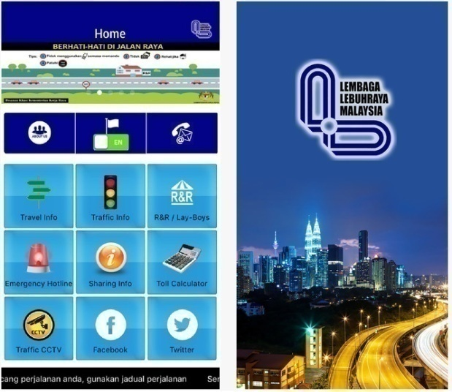

**IJM (Whatscomingtokl) - IJM company app of malaysia (submitting)**

IOS/Android

East Asia secure chatting healthcare (submitting)

IOS/Android/

**Smart Idea Note - photograph app**

https://play.google.com/store/apps/details?id=com.skynote.page&hl=en

https://itunes.apple.com/us/app/smart-idea-note/id1082616276?mt=8

Used skills: book manage, high skill canvas, social network sharing, 2 hand touch detect,

1. **Artificial Intelligence Projects:**

. Express FRS(Face Recognition System)

Protected from client and no any used open source and ourself developped.

Some used techniques:

Scan of face according to luminance and chromaticity.

Converting to gray.

Compensating.

Finding face and eye position. (don’t published)

Extracting feature and matching patern. (don’t published)

Extracting natural feature and checking statistic.

Developed laguange: QT+C++, Visual C++, C#

Deadline: Feb 2007 to Dev 2010

Used devices: infrared lamp, ccd camera and web cam.

. Entrypass FRS(Fingerprint recognition system)

Protected from client

Developed language: Embedded linux, device programming.

Used devices: ARM9, keyboard, SC2440 board.

Deadline: Oct 2010 to Jan 2012.

. Format Recognition System(Exform)

Protected from client

Used some techniques:

Finding horizontal and vertical line and basic point

Compensating resolution of format and basic point and lines. ( don’t published)

Extracting structure and pair of cell. ( don’t published)

Extracting character according to each cell. ( don’t published)

Deadline: Apr 2006 to Dev 2011

. beside this, developed products: CRS(Character Recognition System(no recognize on handwrite)

1. **Experienced Secure Skills:**

To achieve the security goal, the following cryptographic functions should be provided.

* 1. **User Identification**

This is done by our ECDSA (Elliptic Curve Digital Signature Algorithm) with the fastest operations in the world.

The security level of ECDSA is at least 128bit.

We will implement the ECDSA to have a stong resistance against the side-channel analysis, which is the most powerful attack against Elliptic Curve Cryptosystem.

* 1. **Key Exchange**

For this, we employed the ECMQV(Elliptic Curve Menezes-Qu-Vanstone) known as the most practically secure key exchange scheme in the cryptography community.

Our ECMQV can be implemented to have the security and efficieny needed for this system.

* 1. **Data Encryption/Decryption**

To protect the privacy of the Health Data, we use a fast strong block cipher(AES 128 bit) which is provably secure.

The block cipher has a high resistance against all the known cryptographic attacks such as differential/linear cryptanalyses, algebraic attack and side-channel analysis.

The block cipher has the security level greater than 128bit.

All these cryptosystems are competitive with other superior crypto-products in the world.